**EXP NO: 08**

**DATE: 14-04-24**

**Aim:**

Create a simple cloud web application for student counselling system using any Cloud Service Provider to demonstrate SaaS with the fields of student name, age, address, phone, subjects studied, Year of passing, percentage of marks, domain interest, etc.

**Implementation:**

**1. Go to Zoho.com and login/signup**

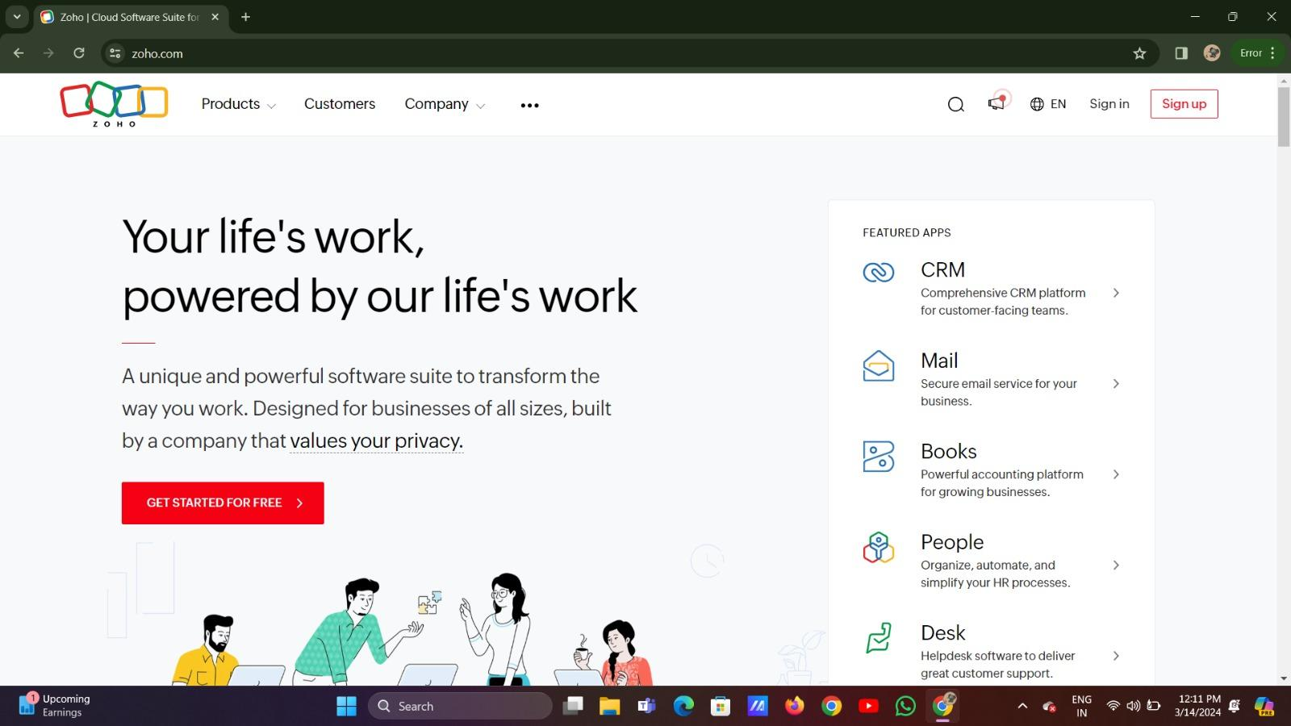

**2. Go to Creator**

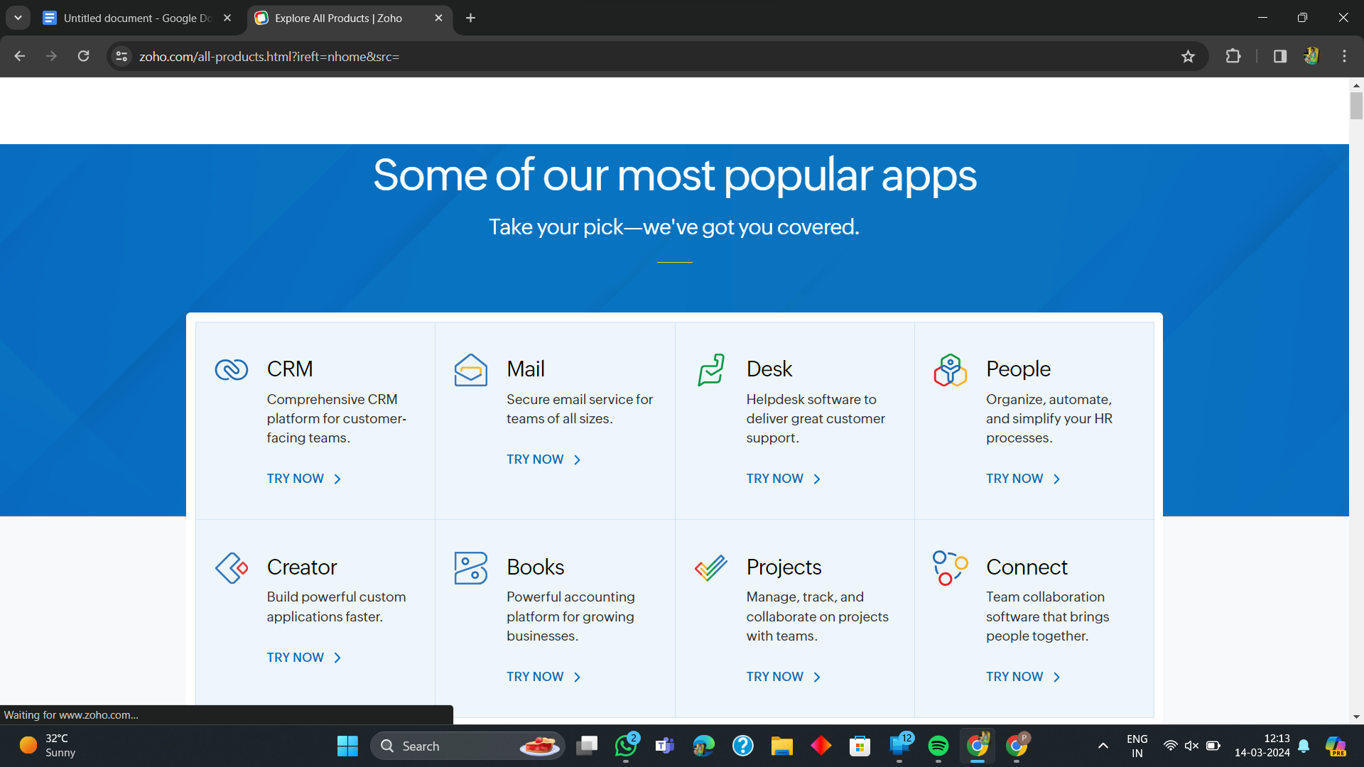

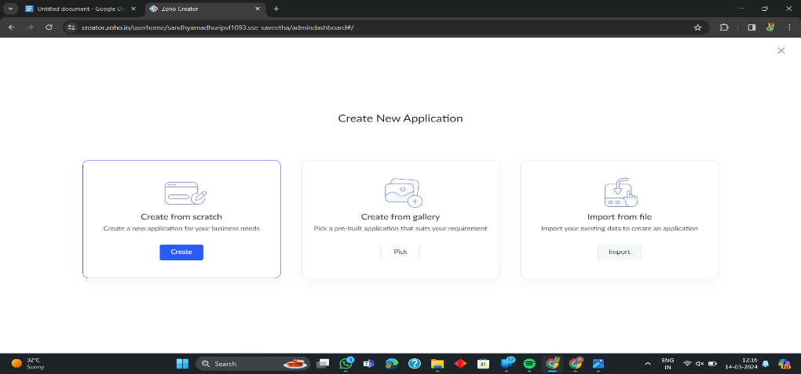**3. Create A New Application**

**4. Given Application Name**

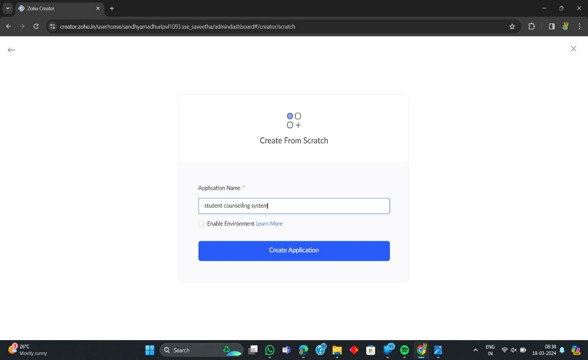

**5. Create New Form**

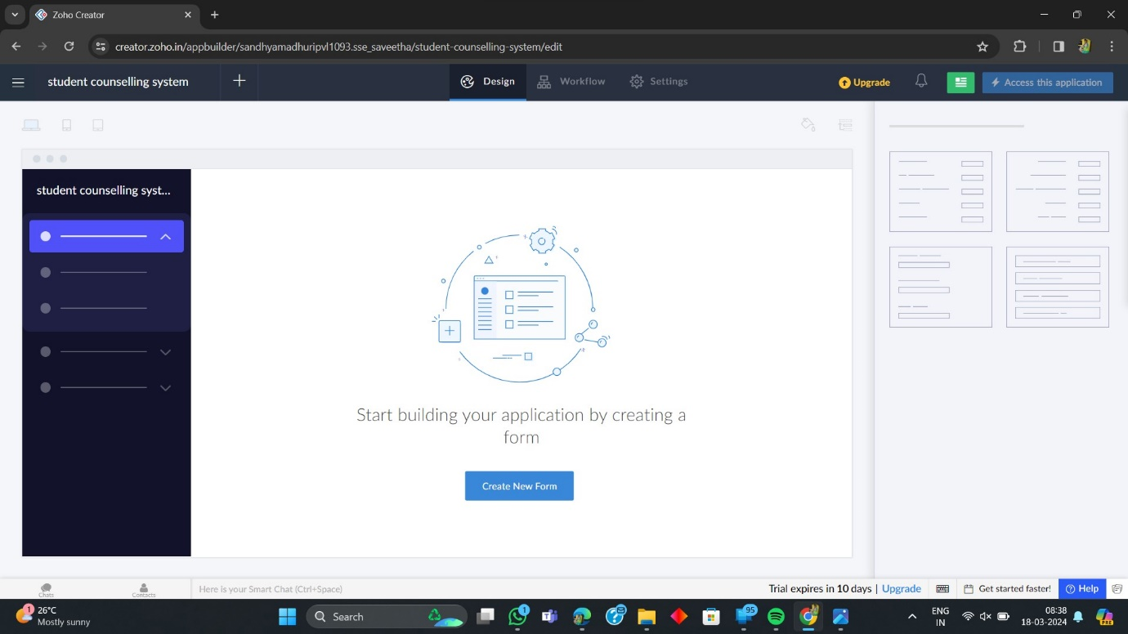

**6. Select Form and Give Name**

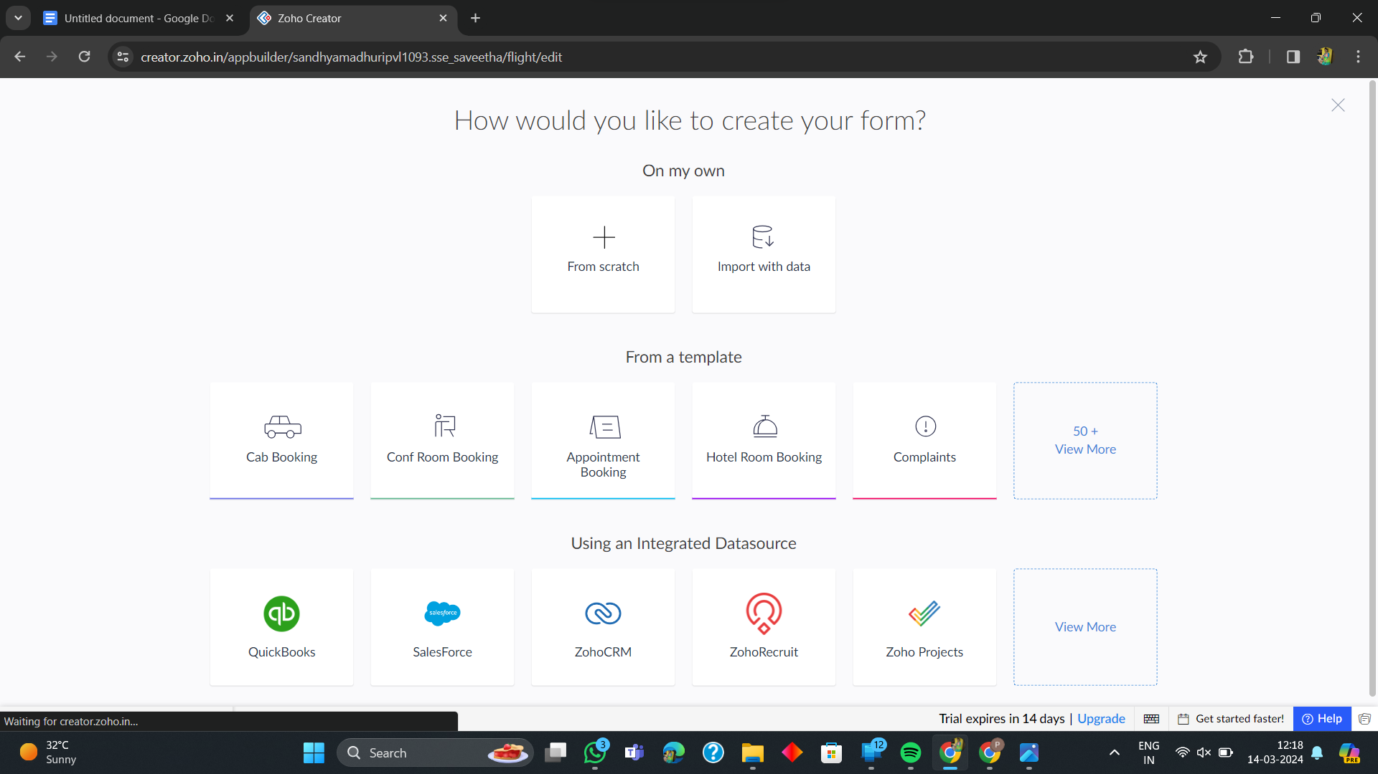

**7. Create from scratch**

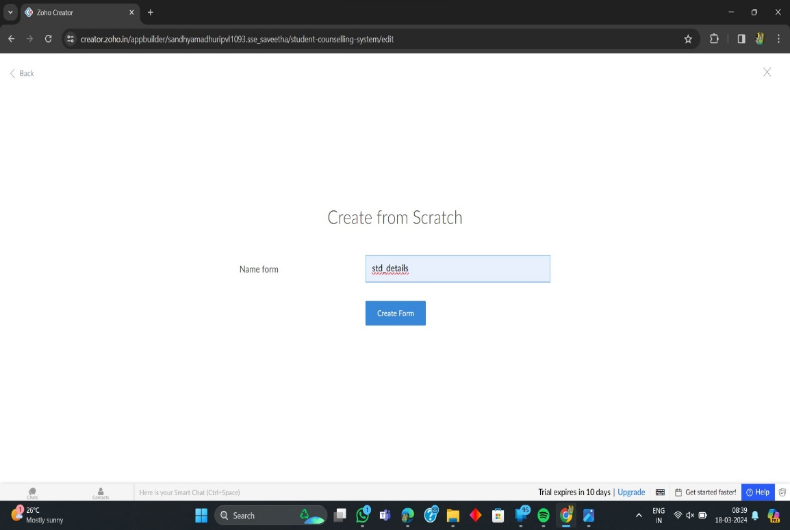

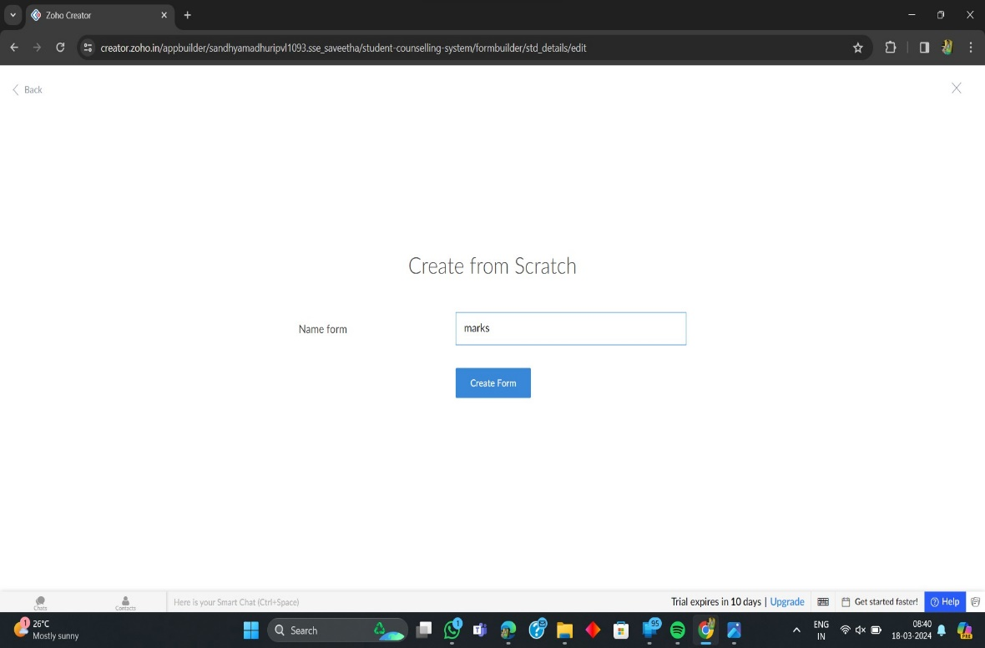

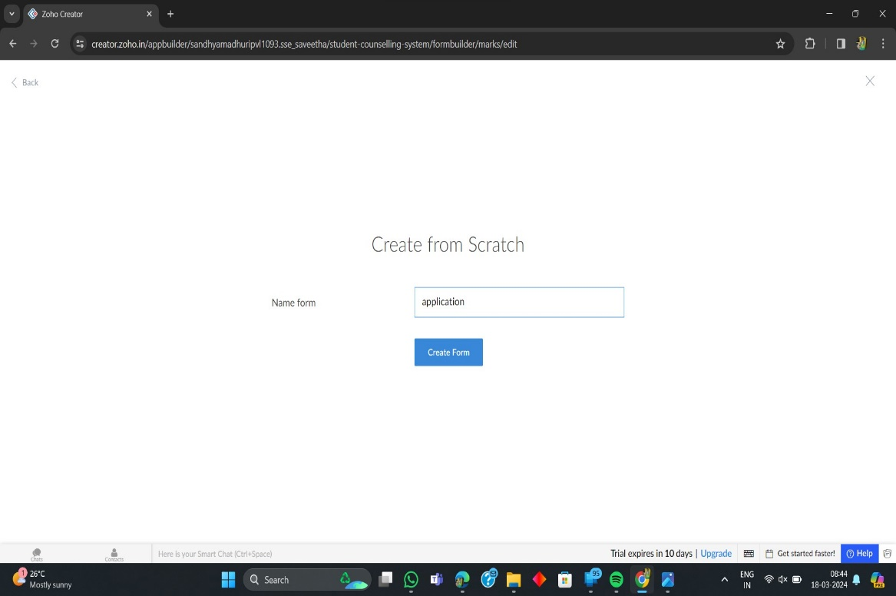

**8. The Software Has been created**

